Integrate! V 0.Alpha!

A mathematics visualization tool

UI layout

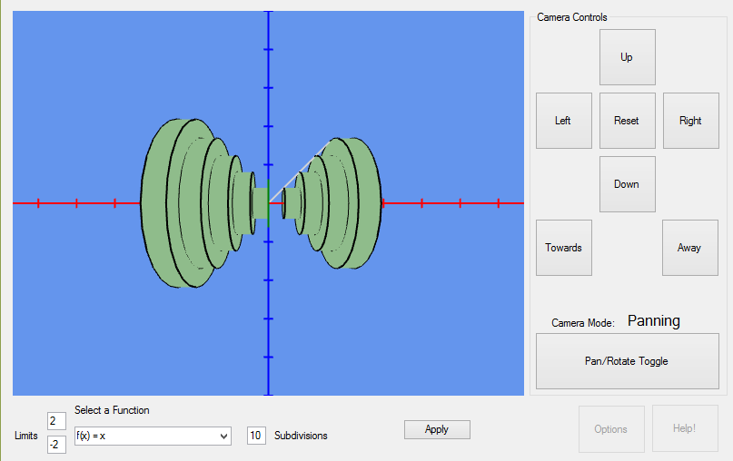

**Limits:** The upper box is the upper limit, and the bottom is the lower. This is organized in roughly the same way that an integral is normally.

**Select a function:** Currently supports a handful of basic functions. In a later version, more will be added, as well as support for any valid function you can enter.

**Subdivisions:** The number of cylinders to make. The number in this box may not match the number visible because they may have a radius of zero. This is most pronounced with a low number of subdivisions, as seen in the default function (first cylinder in the +X direction has a radius of 0)

**Apply button:** calculate and display the function. Changing things in the boxes without pressing this will have no effect on what is displayed in the viewport.

**Camera Controls:** In pan mode, the buttons move the camera physically up, left, right, and down. Pressing the reset button puts the camera back where it is when the program is first launched, cancelling all rotations and translations of the camera. Towards and Away are not affected by the mode toggle button. They always move the camera along the Z axis.

Pressing the toggle mode button will change how the camera reacts when the buttons are pressed. It also changes the labels on the Up and Down buttons to more accurately reflect what they do. However, due to the way that the camera is moved currently, rotation is less than intuitive. It doesn’t always move the way it’s expected to, unfortunately, and can do strange things if rotated in more than one way.

In addition to the on-screen controls, there are keyboard controls as well. They only work when the viewport is selected, so if you press keys but nothing happens, click anywhere on the image of the graph and try again. The keyboard controls are:

|  |  |
| --- | --- |
| **W** | Pan upwards |
| **A** | Pan left |
| **S** | Pan down |
| **D** | Pan right |
| **Q** | Rotate around Y axis to the left |
| **E** | Rotate around Y axis to the right |
| **R** | Pan forwards (zoom in) |
| **F** | Pan backwards (zoom out) |
| **T** | Rotate around X axis (move above the graph) |
| **G** | Rotate around X axis (move under the graph) |

These controls are not affected by the camera mode toggle button.

**Help and Options:** At the moment these two features are disabled, as they are not yet complete. Help will launch an in-app version of this document (or something similar) and Options will contain configurable options, such as colors, outlines and etc. These features will be enabled in future versions.

This project’s full source code can be found [here](https://github.com/peternogg/Integrate) on github, and the latest compiled executables at the release page [here](https://github.com/peternogg/Integrate/releases). You can submit a bug report/feature idea in the [issue tracker](https://github.com/peternogg/Integrate/issues) for this project. If you have any direct questions you need answered, you can email [peternogg@gmail.com](mailto:peternogg@gmail.com). However, I ask that you direct most messages to the issue tracker.

Some features are not yet complete at this time, but they will be added and updates released soon. At the moment, things left to be completed are

* A camera that moves in a way that makes sense (like every other video game camera)
* Using the mouse to rotate the camera
* ~~Options/Preferences window~~ Done!
* ~~Arbitrary functions instead of only preset ones~~ Done!
* Other shapes instead of only cylinders (both 2d and 3d)
* Evaluating integrals w/ Simpson’s rule
* Labels for things (axes, those line things that denote units, etc.)
* ~~Fix tab ordering for controls~~ Done!
* Add control tooltips